Ideation Phase
Emphathize & Discover

Date | 4 March 2026
Team ID | SWTID-2026-2834
Project Name | Automating Data Import and Relationship Mapping Using Import Sets & Dot Walking
Maximum Marks | 4 Marks

Empathy Map Canvas:

An empathy map is a simple visual tool used to understand the user’s behaviors, thoughts, and feelings while interacting with a system. It helps to analyze what the user says, thinks, does, and feels during the process. By studying these aspects, developers can clearly identify the user’s needs, problems, and expectations. The benefits include clear insight into user behavior, reduced errors, improved workflow, better decision-making, and increased user satisfaction, making processes and systems more effective and aligned with actual user needs. It also helps teams design better solutions and improve the overall user experience.

Example:

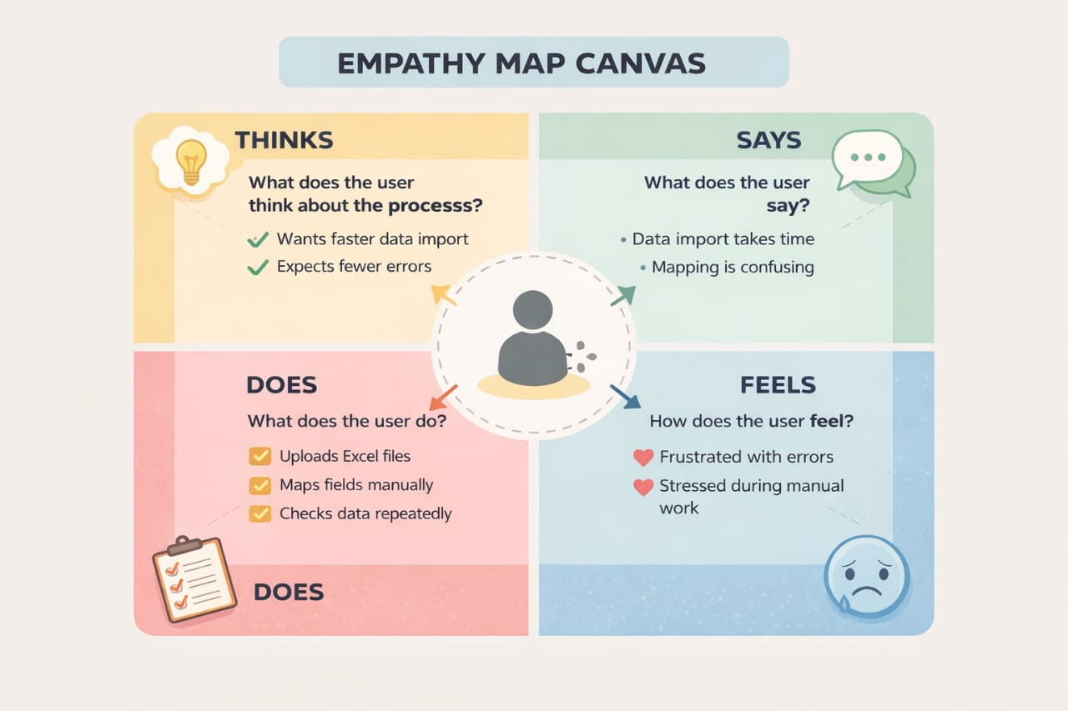

ReferenceLink:https://www.mural.co/framework/empathy-map-canvas⁠

